Assignment 1

By JingjianGao

U84405748

### Question #1:

1. What are the mean and standard deviation of total call center demand according to your simulation?

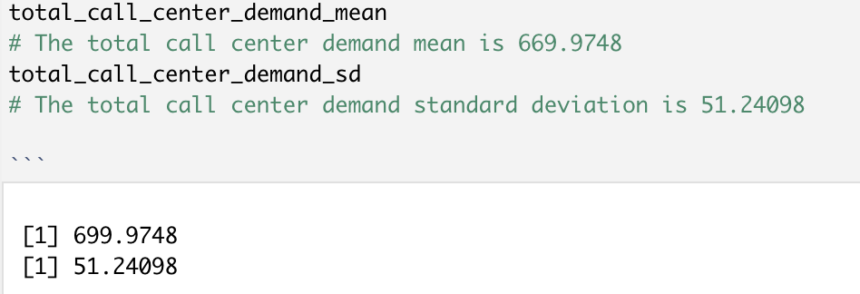

The Total call center demand mean is 699.9748

The total call center demand standard deviation is 51.24098

1. Develop a histogram that models the risk profile for total call center demand.

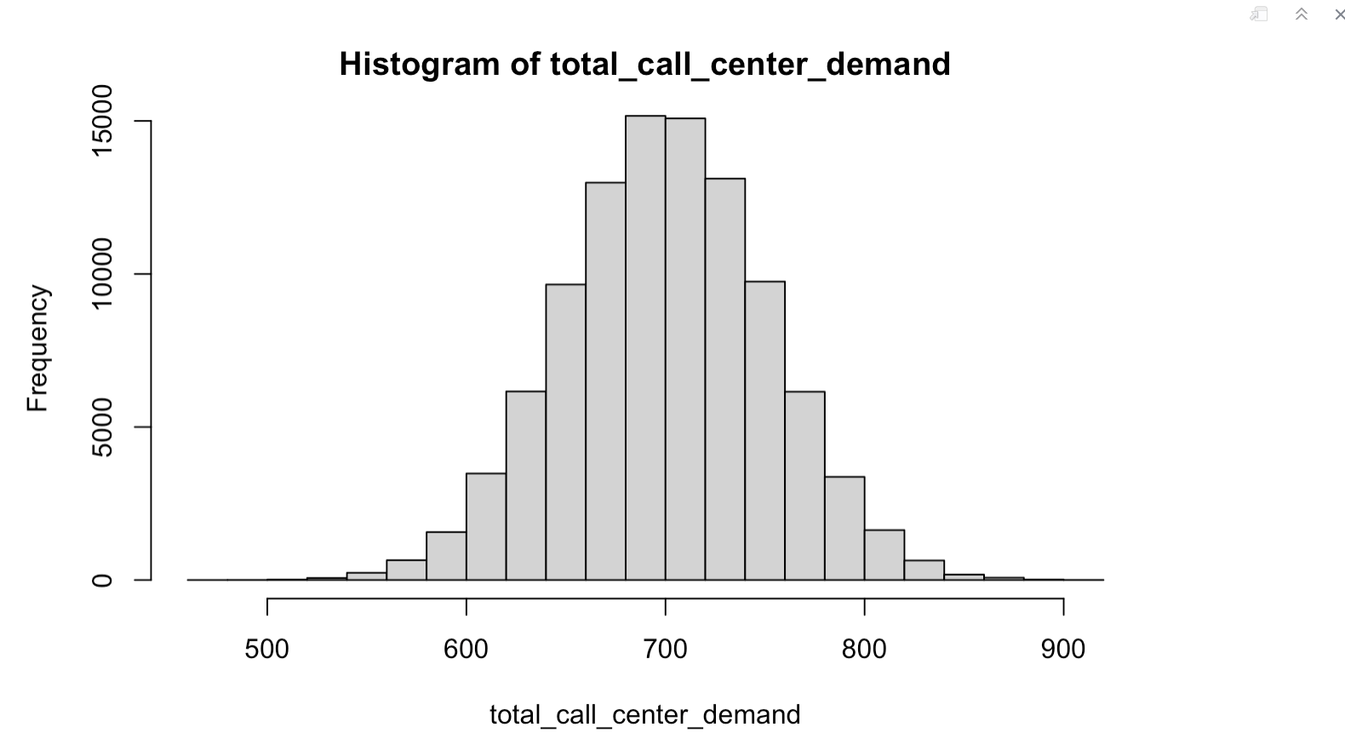

### Question #2:

1. According to your simulation, what is the expected cost per cell phone to the manufacturer of this offer?

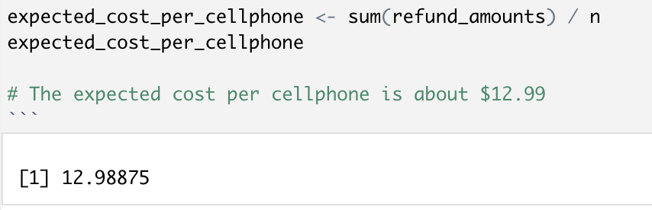

1. According to your simulation, what is the probability a refund will be paid?

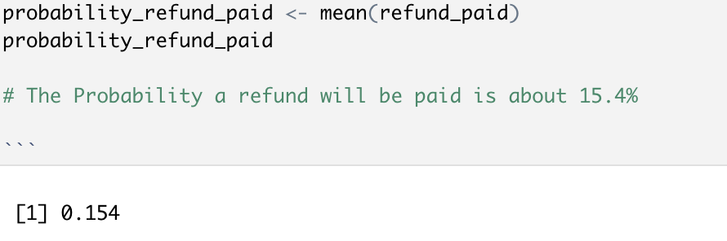

1. According to your simulation, what is the average cost per refund?

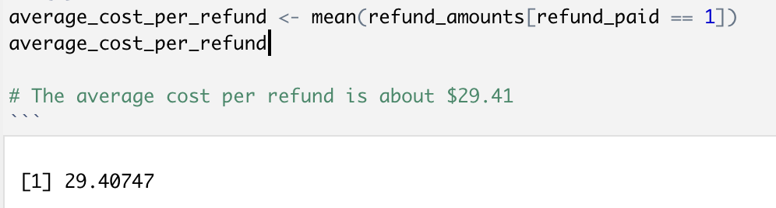

### Question #3:

1. For each option, what is the expected profit, and which option results in the highest expected profit?

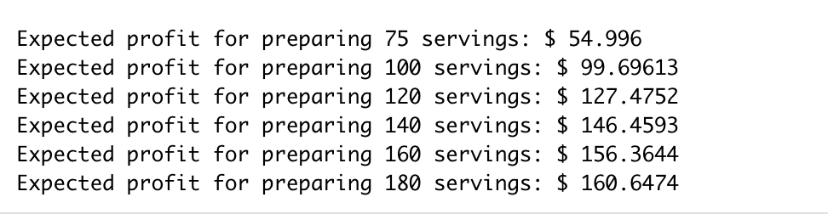

1. Create a histogram that displays the risk profile of profit for the number of servings with the highest expected profit.

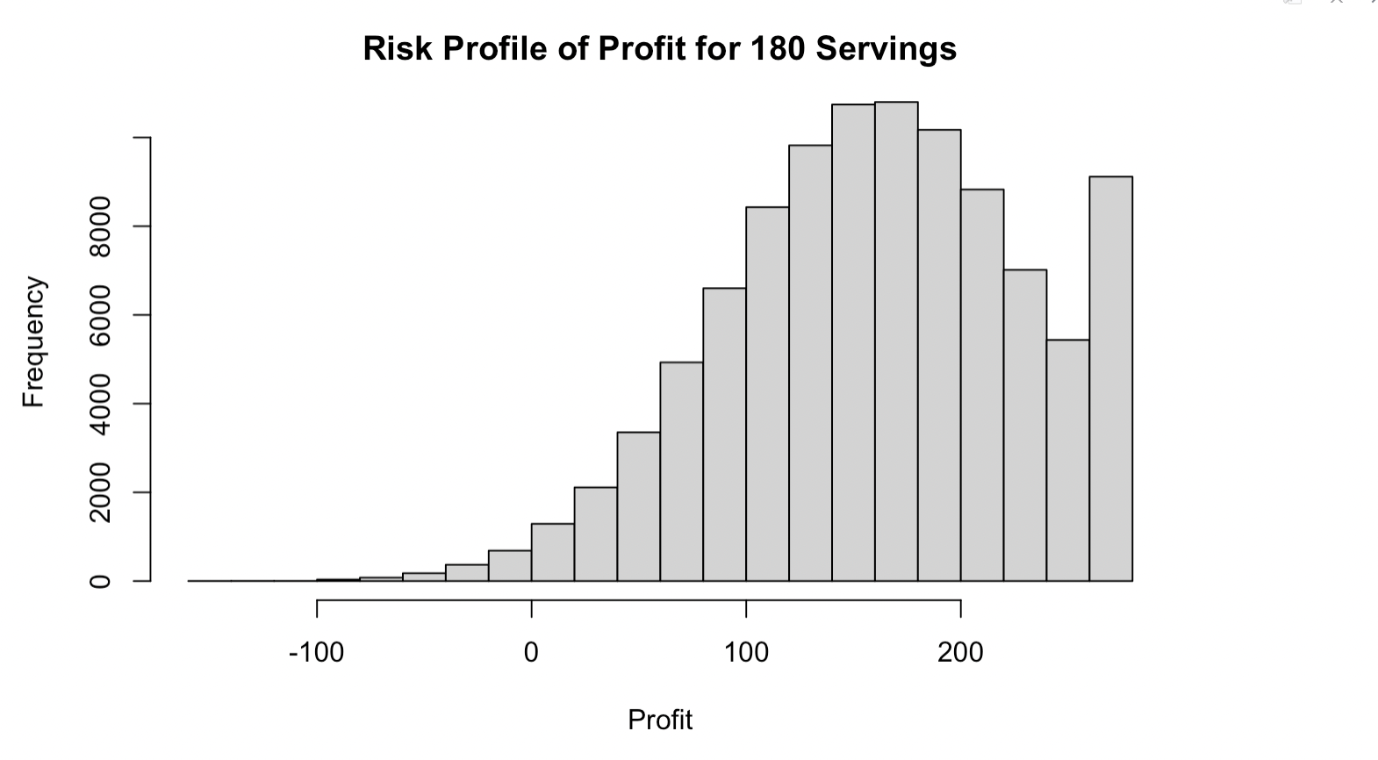

180 servings has the highest expected profit.